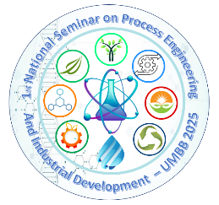**1st National Seminar on Process Engineering**

**and Industrial Development**

**(NSPEID’25)**

**05 & 06 November 2025**

**COMMUNICATION TITLE** (bold, 14 pt, centered)

**Name Surname1**\*, Name Surname2,Name Surname3 (normal font, 12 pt, centered, with presenting author‘s name bold)

1 *Author Affiliation (italic, 10 pt, centered)*

2 *Author Affiliation*

*3* *Author Affiliation*

*\**Email of communicant: (normal font, 11 pt, centered)

**Abstract:**

This electronic document provides the formatting guidelines for abstract submissions to the 1st National Seminar on Process Engineering and Industrial Development. It serves as a template for preparing abstracts using a Microsoft Word typesetting system. The abstract should be between 150 and 250 words and must clearly present the context, objective, methodology, results, and originality of the research.

The abstract should be typed in Times New Roman, 12-point font, single-spaced and justified, with a 2.5 cm margin on the left side, a 2 cm margin on the right and top, and a 1 cm margin at the bottom.

**Key words**: Include a maximum of 6 keywords.